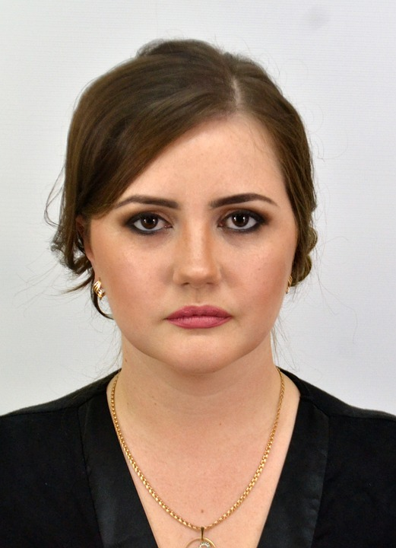

Name: Laura

Age: 29

Email: angela2134@gmail.com

Data Scientist

Skills: R , python , beautifulsoup , git